**Bug Id:01**

**Title:** In this bug, the page becomes unresponsive when clicking on the numbers of results.

**Reporting Date:** 27/07/2022

**Reporter:** Hamza Quraish

**Test Environment:** All Browsers/QA Environment

**Severity:** High

**Priority:** High

**Issue Type:** Crash

**Frequency:** Every Time

**Action Performed**

1. Open [**https://academybugs.com**](https://academybugs.com/)
2. Click the Find Bugs link on the navigation bar
3. Click on the buttons to show a certain number of results at the top left

**Expected Result**

The selected number of results is displayed according to the clicked buttons

**Actual Result**

The page freezes when clicking on the numbers of results

**Attachments**

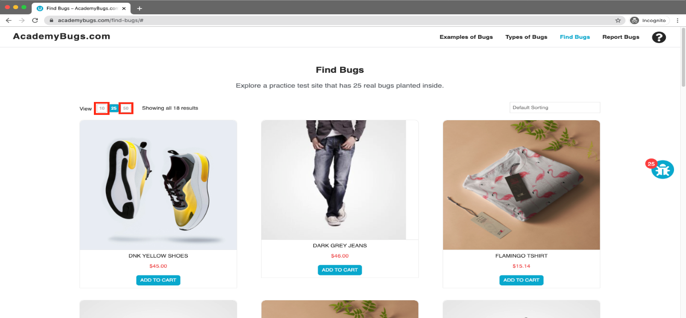

**Bug Id:02**

**Title:** In this bug, the page freezes when changing the currency.

**Reporting Date:** 27/07/2022

**Reporter:** Hamza Quraish

**Severity:** High

**Priority:** High

**Issue Type:** Crash

**Frequency:** Every Time

**Environment:** All Browsers/QA Environment

**Action Performed**

1. Open [**https://academybugs.com**](https://academybugs.com/)
2. Click the Find Bugs link on the navigation bar
3. Open a product
4. Change the currency in the right side menu

**Expected Result**

The currency is changed as expected

**Actual Result**

The page freezes when changing the currency

**Attachments**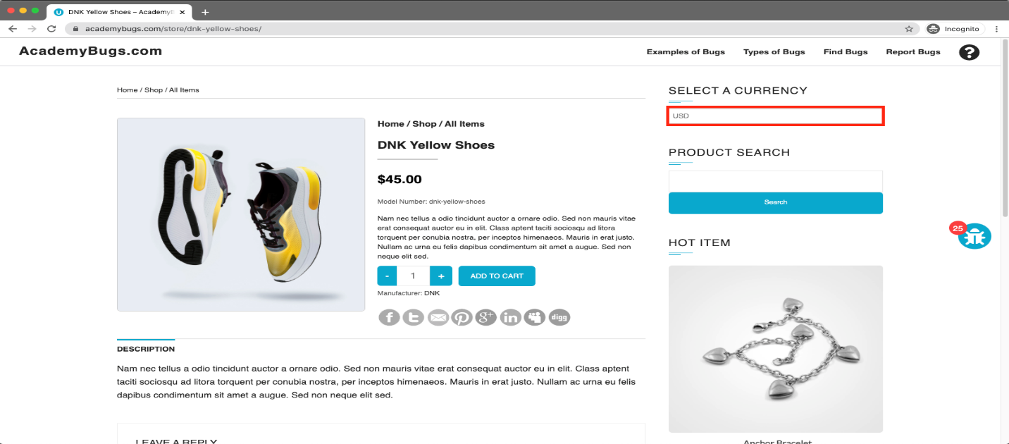

**Bug Id:03**

**Title:** In this bug, the image is not completely displayed.

**Reporting Date:** 27/07/2022

**Reporter:** Hamza Quraish

###### Severity: Medium

###### Priority: Low

###### Issue Type: Visual

###### Frequency: Every Time

###### Environment: All Browsers/ QA Environment

###### Action Performed

1. Open [**https://academybugs.com**](https://academybugs.com/)
2. Click the Find Bugs link on the navigation bar
3. Click on "Dark Grey Jeans"

###### Expected Result

The product image fills the box entirely

###### Actual Result

The image has a white space on the right

###### Attachments

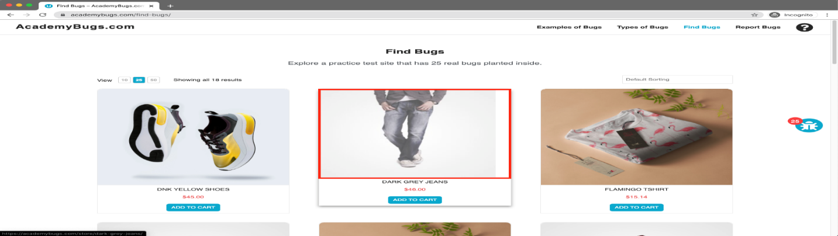

**Bug Id:**04

**Title:** In this bug, the product quantity cannot be increased past 2.

**Reporting Date:** 27/07/2022

**Reporter:** Hamza Quraish

###### Severity: High

###### Priority: High

###### Issue Type: Functional

###### Frequency: Every Time

###### Environment: All Browsers/QA Environment

###### Action Performed

1. Open [**https://academybugs.com**](https://academybugs.com/)
2. Click the Find Bugs link on the navigation bar
3. Add one or more products to the cart
4. Click the "View cart" link on top of the page
5. Set the products quantity to 3 or more
6. Click "update" below

###### Expected Result

The product quantity can be increased past 2

###### Actual Result

When clicking on the update button the product quantity becomes 2 again

###### Attachments

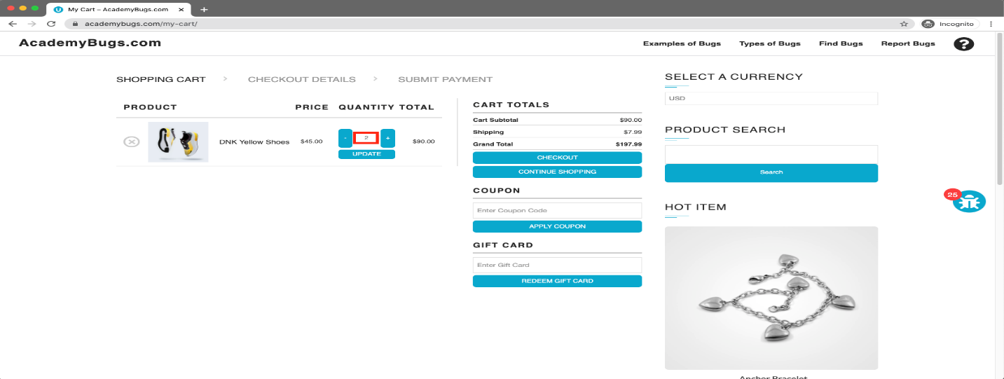

**Bug Id:05**

**Title:** In this bug, the page becomes unresponsive when clicking on the Post Comment button.

**Reporting Date:** 27/07/2022

**Reporter:** Hamza Quraish

###### Severity: High

###### Priority: High

###### Issue Type: Crash

###### Frequency: Every Time

###### Environment: All Browsers/QA Environment

###### Action Performed

1. Open [**https://academybugs.com**](https://academybugs.com/)
2. Click the Find Bugs link on the navigation bar
3. Open a product
4. Scroll down to the Leave a Reply section
5. Fill out the comment form
6. Click "Post Comment"

###### Expected Result

The comment is posted under the product

###### Actual Result

The page becomes unresponsive when clicking on "Post Comment"

###### Attachments

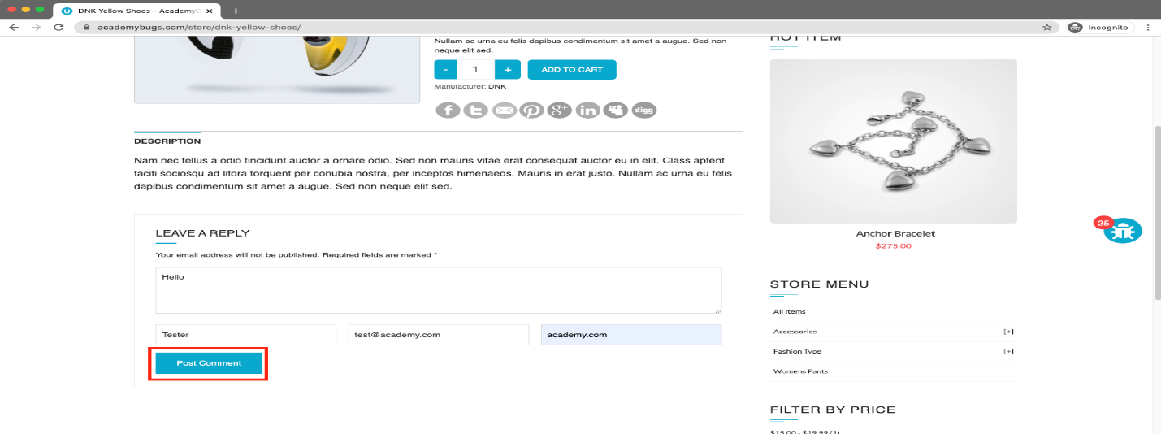

**Bug Id:06**

**Title:** In this bug, the page freezes when increasing the product quantity having green or pink colors chosen.

**Reporting Date:** 27/07/2022

**Reporter:** Hamza Quraish

###### Severity: High

###### Priority: High

###### Issue Type: Crash

###### Frequency: Every Time

###### Environment: All Browsers/QA Environment

###### Action Performed

1. Open [**https://academybugs.com**](https://academybugs.com/)
2. Click the Find Bugs link on the navigation bar
3. Open a product that has color options
4. Choose the pink or green color
5. Increase the product quantity by 1 or more

###### Expected Result

The quantity is increased to a desired value

###### Actual Result

The page becomes unresponsive when increasing the quantity with the pink or green colors chosen

###### Attachments

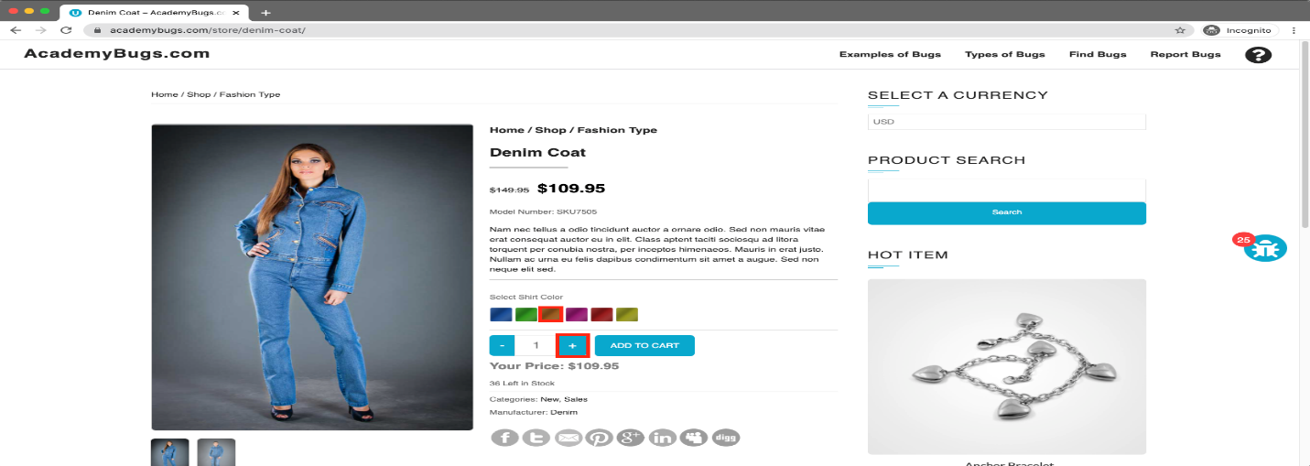

**Bug Id:07**

**Title:** In this bug, the twitter share button in the product details page is broken.

**Reporting Date:** 27/07/2022

**Reporter:** Hamza Quraish

###### Severity: Medium

###### Priority: low

###### Issue Type: Functional

###### Frequency: Every Time

###### Environment: All Browsers/QA Environment

###### Action Performed

1. Open [**https://academybugs.com**](https://academybugs.com/)
2. Click the Find Bugs link on the navigation bar
3. Open a product
4. Click the twitter share button

###### Expected Result

The twitter share button shows an appropriate page

###### Actual Result

The twitter share button shows an error page

###### Attachments

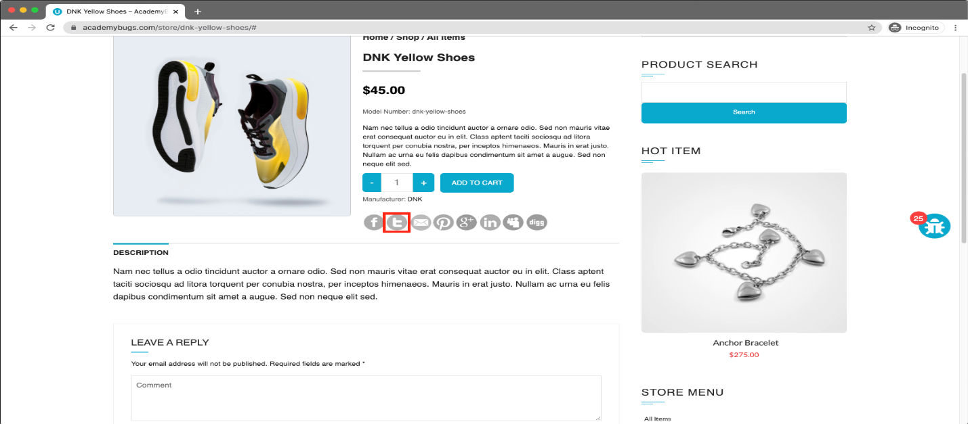

**Bug Id:08**

**Title:** In this bug, the short description and description of the product are not in English.

**Reporting Date:** 27/07/2022

**Reporter:** Hamza Quraish

###### Severity: Medium

###### Priority: High

###### Issue Type: Content

###### Frequency: Every Time

###### Environment: All Browsers/QA Environment

###### Action Performed

1. Open [**https://academybugs.com**](https://academybugs.com/)
2. Click the Find Bugs link on the navigation bar
3. Open a product

###### Expected Result

The short description and description of the product are in English

###### Actual Result

The short description and description of the product are not in English

###### Attachments

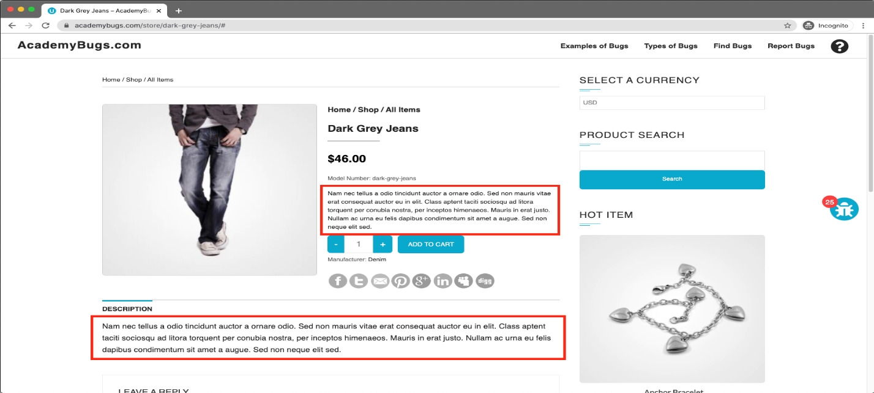

**Bug Id:09**

**Title:** In this bug, the Sign In button overlaps the footer.

**Reporting Date:** 27/07/2022

**Reporter:** Hamza Quraish

###### Severity: Low

###### Priority: low

###### Issue Type: Visual

###### Frequency: Every Time

###### Environment: All Browsers/QA Environment

###### Action Performed

1. Open [**https://academybugs.com**](https://academybugs.com/)
2. Click the Find Bugs link on the navigation bar
3. Open a product
4. Scroll down to the bottom of the right side menu

###### Expected Result

The Sign In button is above the footer

###### Actual Result

The Sign In button overlaps the footer

###### Attachments

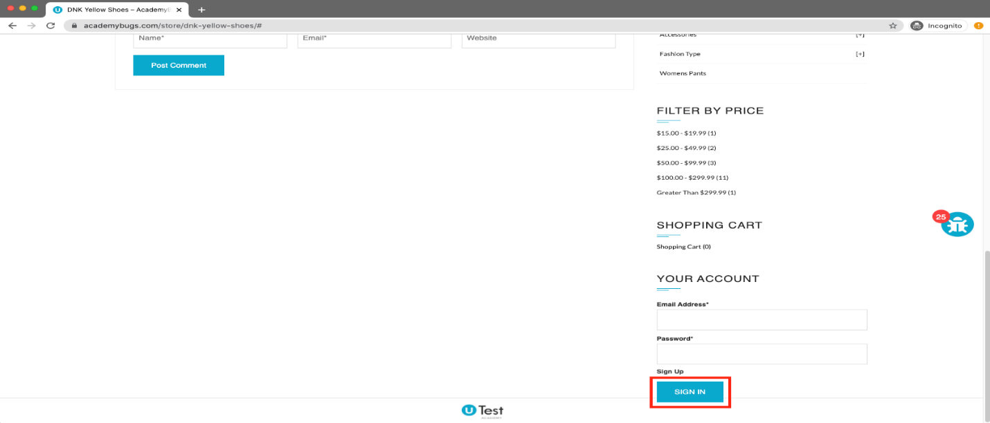

**Bug Id:10**

**Title:** In this bug, there are unreadable symbols in the shopping cart popup.

**Reporting Date:** 27/07/2022

**Reporter:** Hamza Quraish

###### Severity: Low

###### Priority: High

###### Issue Type: Content

###### Frequency: Every Time

###### Environment: All Browsers

###### Action Performed

1. Open [**https://academybugs.com**](https://academybugs.com/)
2. Click the Find Bugs link on the navigation bar
3. Add one or more products to the cart
4. Click "View Cart" on top of the page
5. Scroll down to the Shopping Cart section of the right side menu
6. Hover over the Shopping Cart caption

###### Expected Result

All characters are clear to a regular user

###### Actual Result

There are unreadable symbols in the shopping cart popup

###### Attachments

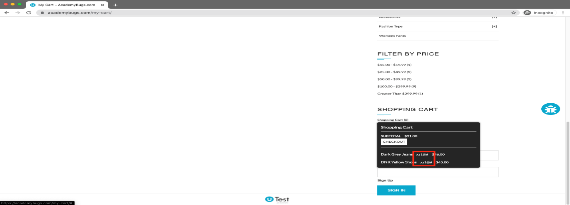

**Bug Id:11**

**Title:** In this bug, the yellow and orange colors of the product are misspelled.

**Reporting Date:** 27/07/2022

**Reporter:** Hamza Quraish

###### Severity: Low

###### Priority: Low

###### Issue Type: Content

###### Frequency: Every Time

###### Environment: All Browsers/QA Environment

###### Action Performed

1. Open [**https://academybugs.com**](https://academybugs.com/)
2. Click the Find Bugs link on the navigation bar
3. Open a product with color options
4. Choose the Yellow and Orange colors

###### Expected Result

The yellow and orange colors are spelled correctly

###### Actual Result

Yellow is misspelled as "Yelow" and Orange as "Orang"

###### Attachments

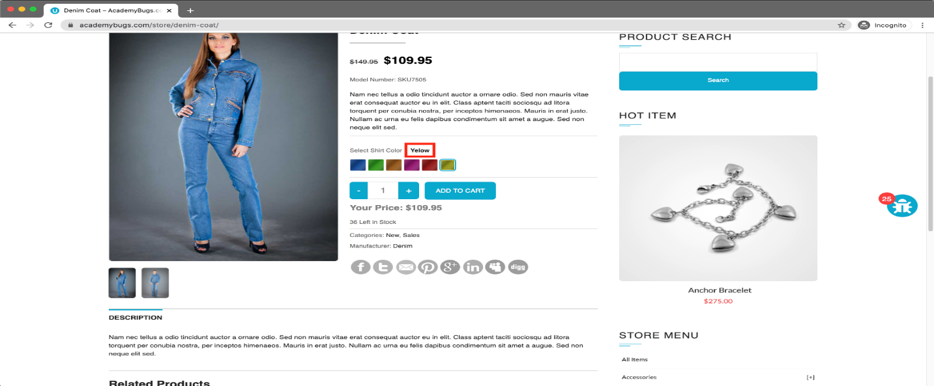

**Bug Id:12**

**Title:** In this bug, the manufacturer link in the product details page is broken.

**Reporting Date:** 27/07/2022

**Reporter:** Hamza Quraish

###### Severity: Medium

###### Priority: High

###### Issue Type: Functional

###### Frequency: Every Time

###### Environment: All Browsers/QA Environment

###### Action Performed

1. Open [**https://academybugs.com**](https://academybugs.com/)
2. Click the Find Bugs link on the navigation bar
3. Open a product
4. Click the manufacturer link under the quantity

###### Expected Result

The manufacturer link shows an appropriate page

###### Actual Result

The manufacturer link opens an error page

###### Attachments

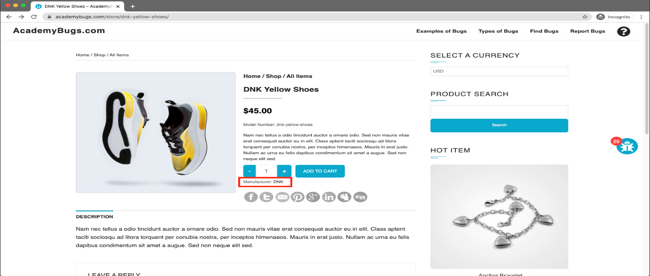

**Bug Id:13**

**Title:** In this bug, the filter by price doesn't work in the product details page.

**Reporting Date:** 27/07/2022

**Reporter:** Hamza Quraish

###### Severity: Medium

###### Priority: High

###### Issue Type: Functional

###### Frequency: Every Time

###### Environment: All Browsers/QA Environment

###### Action Performed

1. Open [**https://academybugs.com**](https://academybugs.com/)
2. Click the Find Bugs link on the navigation bar
3. Open a product
4. On the right side menu find the Filter by Price section
5. Select any of the price ranges

###### Expected Result

A list of products in the selected price range is shown

###### Actual Result

The same page reloads

###### Attachments

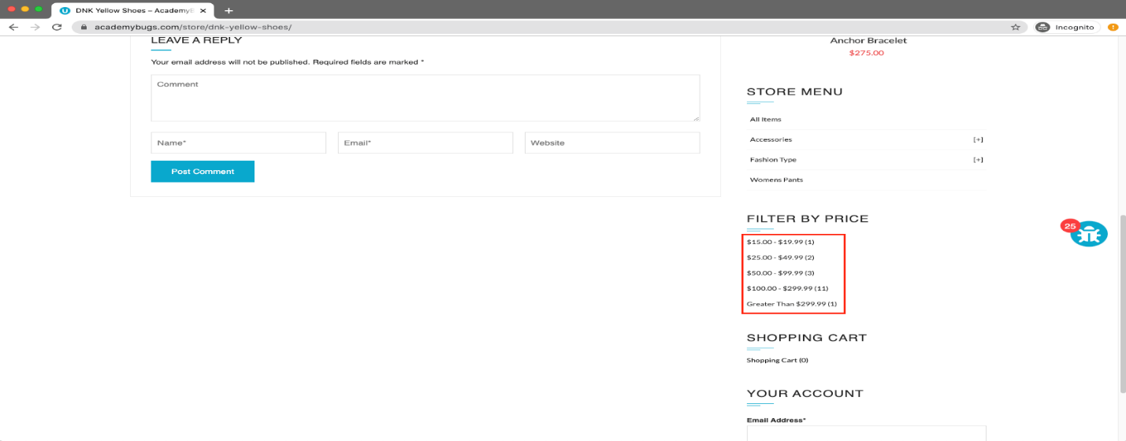

**Bug Id:14**

**Title:** In this bug, the page becomes unresponsive when clicking on the Retrieve Password button.

**Reporting Date:** 27/07/2022

**Reporter:** Hamza Quraish

###### Severity: High

###### Priority: High

###### Issue Type: Crash

###### Frequency: Every Time

###### Environment: All Browsers/QA Environment

###### Action Performed

1. Open [**https://academybugs.com**](https://academybugs.com/)
2. Click the Find Bugs link on the navigation bar
3. Open a product
4. Scroll down to the Your Account section of the right side menu
5. Click "Sign Up"
6. In the Returning Customer section click "Forgot Your Password?"
7. Enter your email in the field and click "Retrieve Password"

###### Expected Result

The password is sent to the entered email

###### Actual Result

The page becomes unresponsive when clicking on "Retrieve Password" and no email is sent

###### Attachments

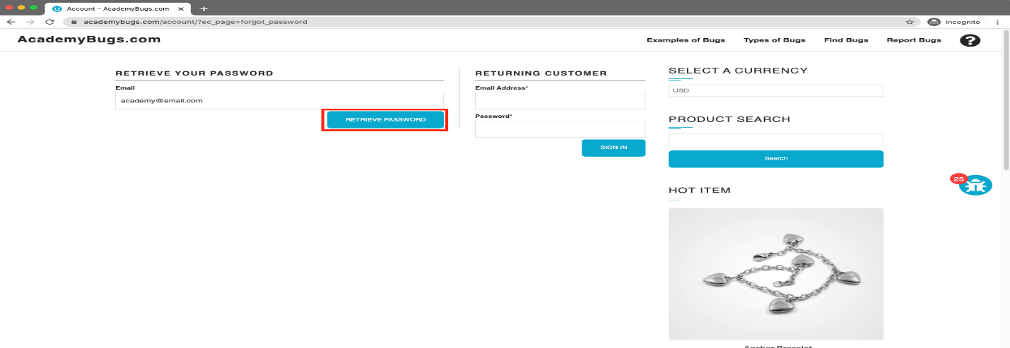

**Bug Id:15**

**Title:** In this bug, the text under the New User section is not in English.

**Reporting Date:** 27/07/2022

**Reporter:** Hamza Quraish

###### Severity: Low

###### Priority: High

###### Issue Type: Content

###### Frequency: Every Time

###### Environment: All Browsers/QA Environment

###### Action Performed

1. Open [**https://academybugs.com**](https://academybugs.com/)
2. Click the Find Bugs link on the navigation bar
3. Open a product
4. Scroll down to the bottom of the right side menu
5. Click "Sign In" to open the sign in page

###### Expected Result

The text under the New User section is in English

###### Actual Result

The text under the New User section is in another language

###### Attachments

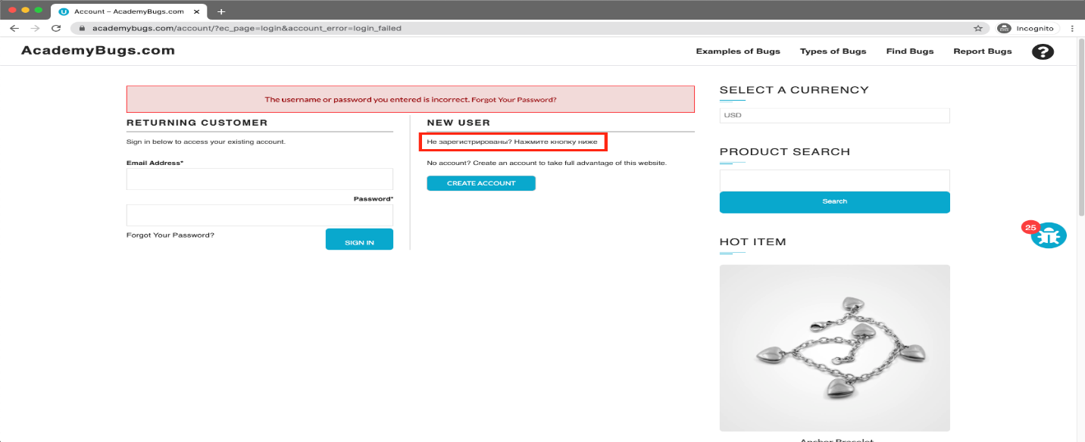

**Bug Id:16**

**Title:** In this bug, the caption of the Sign In button is misaligned vertically.

**Reporting Date:** 27/07/2022

**Reporter:** Hamza Quraish

###### Severity: Low

###### Priority: Low

###### Issue Type: Visual

###### Frequency: Every Time

###### Environment: All Browsers/QA Environment

###### Action Performed

1. Open [**https://academybugs.com**](https://academybugs.com/)
2. Click the Find Bugs link on the navigation bar
3. Open a product
4. Scroll to the bottom and find the sign in form in the right side menu
5. Enter any login and password that are not registered and click "Sign In"

###### Expected Result

The caption of the Sign In button is centered vertically

###### Actual Result

The caption of the Sign In button is misaligned vertically

###### Attachments

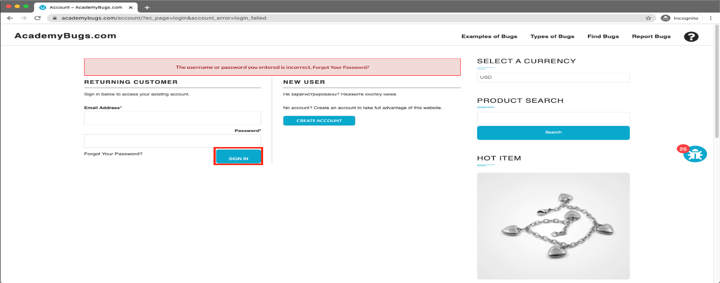

**Bug Id:17**

**Title:** In this bug, the title of the password field is misaligned.

**Reporting Date:** 27/07/2022

**Reporter:** Hamza Quraish

###### Severity: Low

###### Priority: High

###### Issue Type: Visual

###### Frequency: Every Time

###### Environment: All Browsers/QA Environment

###### Action Performed

1. Open [**https://academybugs.com**](https://academybugs.com/)
2. Click the Find Bugs link on the navigation bar
3. Open a product
4. Scroll down to the bottom of the right side menu
5. Click "Sign In" without filling the form to open the Sign In page

###### Expected Result

The title of the password field is aligned the same as the field above

###### Actual Result

The title of the password field is not aligned the same as the field above

###### Attachments

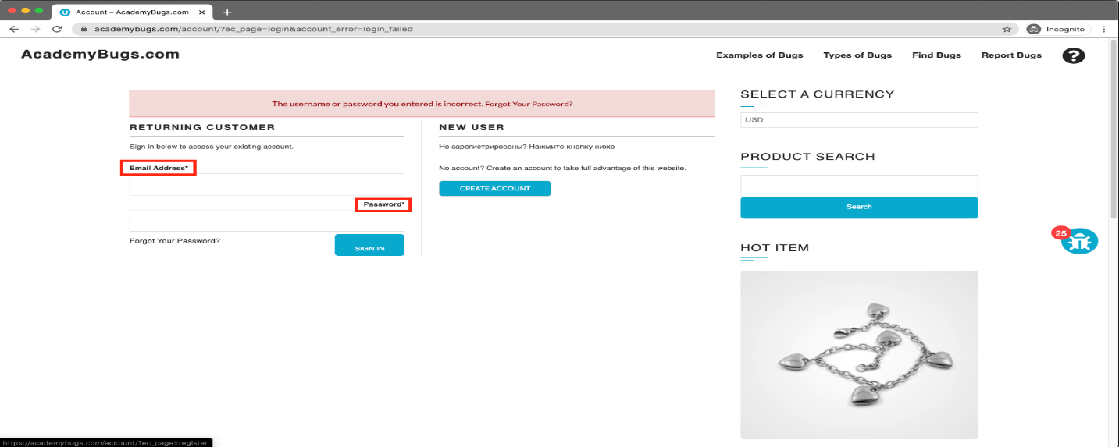

**Bug Id:18**

**Title:** In this bug, the billing address loads infinitely.

**Reporting Date:** 27/07/2022

**Reporter:** Hamza Quraish

###### Severity: Medium

###### Priority: High

###### Issue Type: Performance

###### Frequency: Every Time

###### Environment: All Browsers

###### Action Performed

1. Open [**https://academybugs.com**](https://academybugs.com/)
2. Click the Find Bugs link on the navigation bar
3. Open a product
4. Sign up if you are not signed up or log in at the bottom of right side menu
5. At the bottom of the right side menu select Dashboard
6. Scroll up to the Billing Address section

###### Expected Result

The Billing Address section shows appropriate info

###### Actual Result

The Billing Address section loads infinitely

###### Attachments

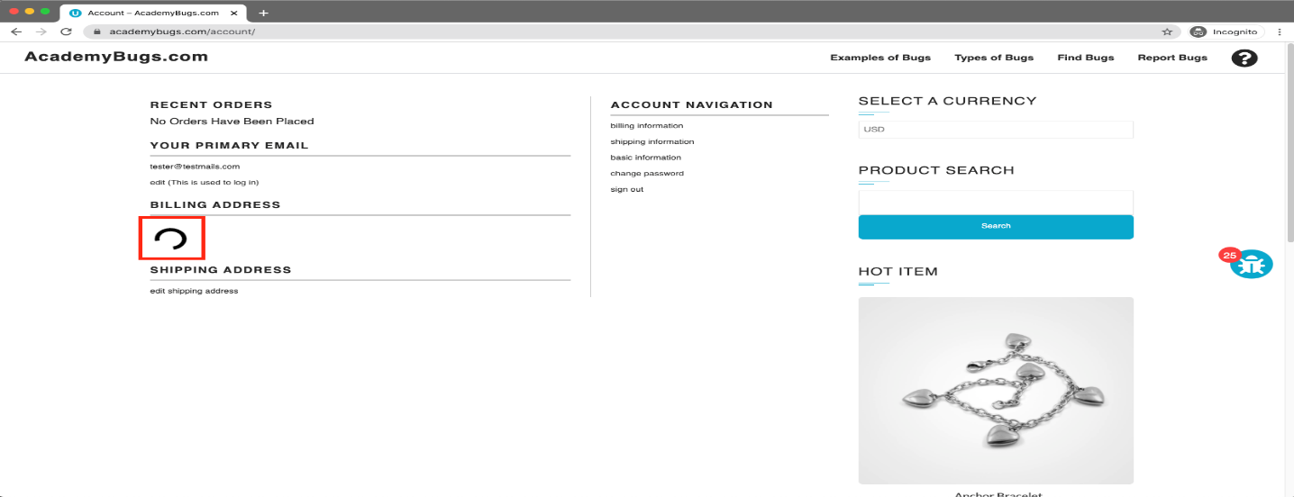

**Bug Id:19**

**Title:** In this bug, the grand total is $100 more than the sum of all products in the cart.

**Reporting Date:** 27/07/2022

**Reporter:** Hamza Quraish

###### Severity: Critical

###### Priority: High

###### Issue Type: Functional

###### Frequency: Every Time

###### Environment: All Browsers/QA Environment

###### Action Performed

1. Open [**https://academybugs.com**](https://academybugs.com/)
2. Click the Find Bugs link on the navigation bar
3. Add one or more products to the cart
4. Click the "View cart" link on top of the page, or click "Continue to Shipping" in the checkout details page

###### Expected Result

The grand total is equal to the sum of all products in the cart

###### Actual Result

The grand total is $100 more than the sum of all products in the cart

###### Attachments

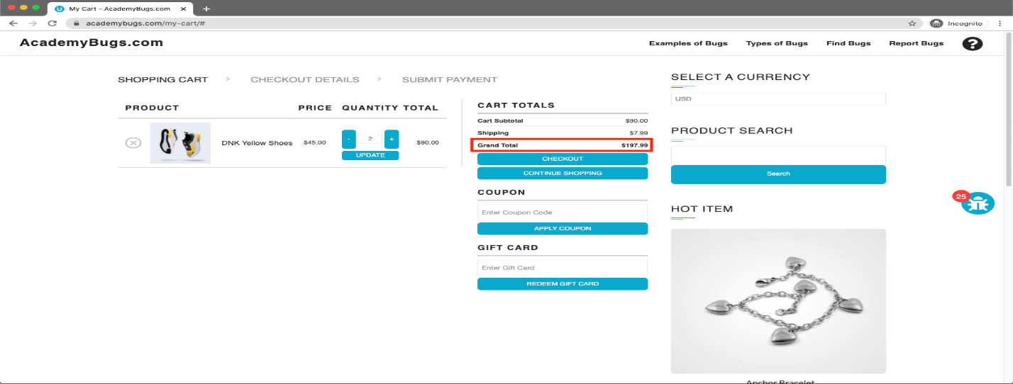

**Bug Id:20**

**Title:** In this bug, there is big space before the last letter in "Return to Store".

**Reporting Date:** 27/07/2022

**Reporter:** Hamza Quraish

###### Severity: Low

###### Priority: High

###### Issue Type: Content

###### Frequency: Every Time

###### Environment: All Browsers/QA Environment

###### Action Performed

1. Open [**https://academybugs.com**](https://academybugs.com/)
2. Click the Find Bugs link on the navigation bar
3. Open a product
4. Open the cart at the bottom of right side menu
5. Clear the cart if there are any items

###### Expected Result

The caption of the "Return to Store" button is written with even spacing between letters

###### Actual Result

There is too much space before the last letter in "Return to Store"

###### Attachments

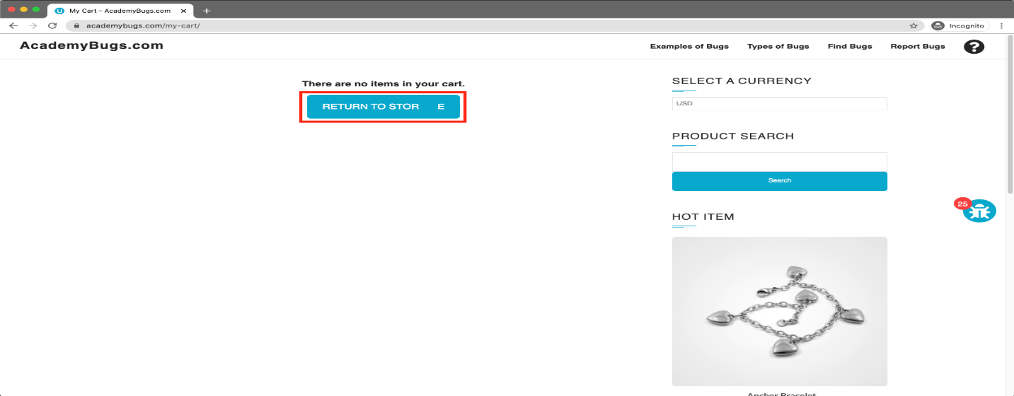

**Bug Id:21**

**Title:** In this bug, the order history loads infinitely.

**Reporting Date:** 27/07/2022

**Reporter:** Hamza Quraish

###### Severity: High

###### Priority: High

###### Issue Type: Performance

###### Frequency: Every Time

###### Environment: All Browsers

###### Action Performed

1. Open [**https://academybugs.com**](https://academybugs.com/)
2. Click the Find Bugs link on the navigation bar
3. Open a product
4. Sign up if you are not signed up or log in at the bottom of right side menu
5. At the bottom of the right side menu select Order History

###### Expected Result

Your Order History section shows appropriate info

###### Actual Result

Your Order History section loads infinitely

###### Attachments

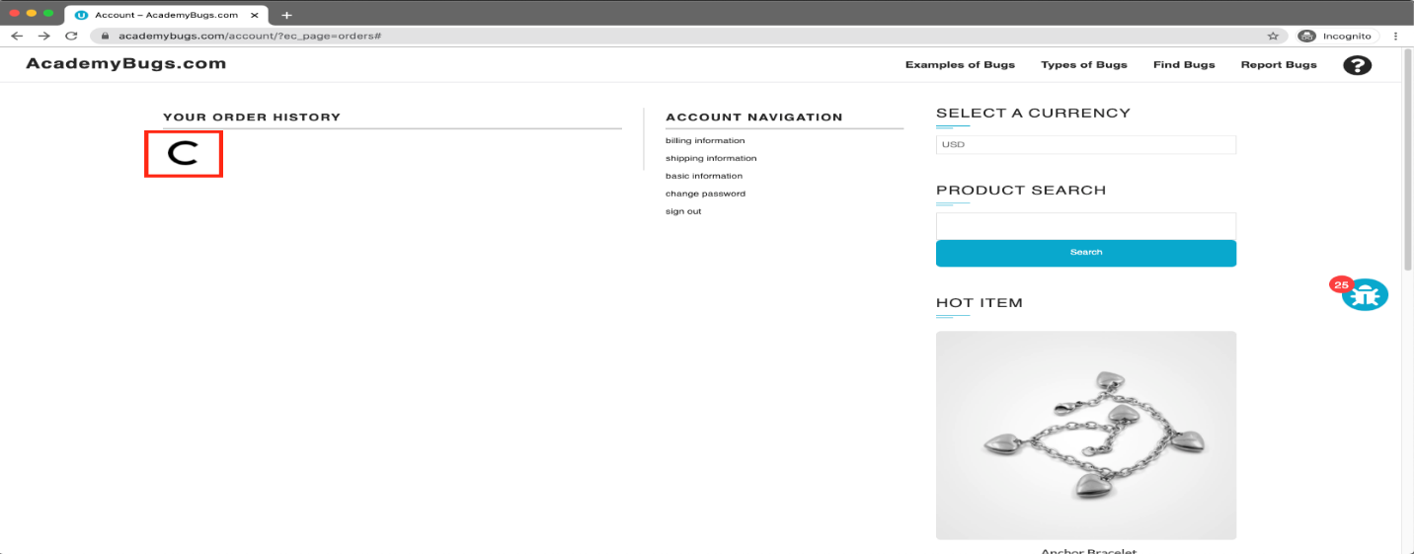

**Bug Id: 22**

**Title:** In this bug, item images have unnecessary space underneath.

**Reporting Date:** 27/07/2022

**Reporter:** Hamza Quraish

###### Severity: Low

###### Priority: High

###### Issue Type: Visual

###### Frequency: Every Time

###### Environment: All Browsers

###### Action Performed

1. Open [**https://academybugs.com**](https://academybugs.com/)
2. Click the Find Bugs link on the navigation bar
3. Open a product
4. Find the Store Menu section in the right side menu
5. Choose All Items

###### Expected Result

Item images have no space underneath

###### Actual Result

Item images have unnecessary space underneath

###### Attachments

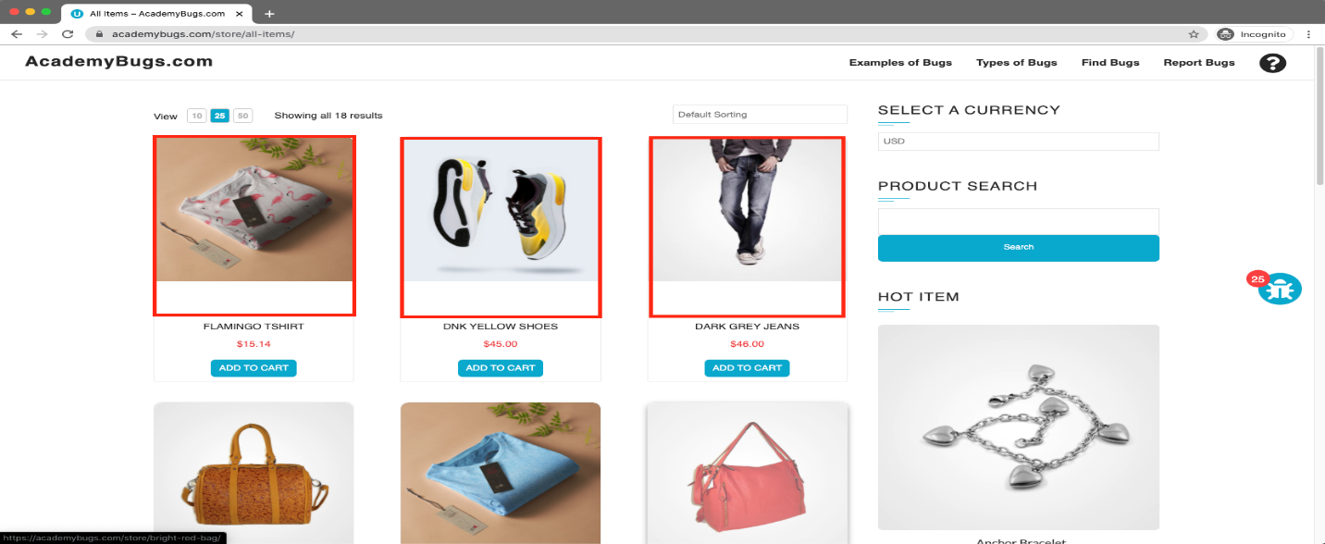

**Bug Id:23**

**Title:** In this bug, the product in the Hot Item section keeps loading.

**Reporting Date:** 27/07/2022

**Reporter:** Hamza Quraish

###### Severity: High

###### Priority: High

###### Issue Type: Performance

###### Frequency: Every Time

###### Environment: All Browsers/QA Environment

###### Action Performed

1. Open [**https://academybugs.com**](https://academybugs.com/)
2. Click the Find Bugs link on the navigation bar
3. Open a product
4. Open the product in the Hot Item section of the right side menu

###### Expected Result

The product in the Hot Item section is displayed

###### Actual Result

The page loads infinitely

###### Attachments

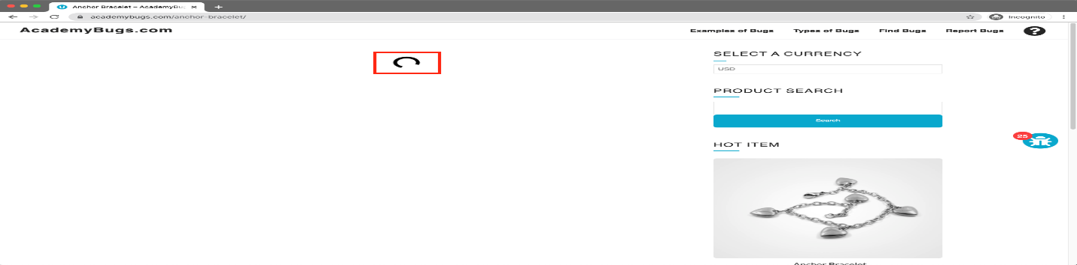

**Bug Id:24**

**Title:** In this bug, the billing information isn't updated.

**Reporting Date:** 27/07/2022

**Reporter:** Hamza Quraish

###### Severity: High

###### Priority: High

###### Issue Type: Performance

###### Frequency: Every Time

###### Environment: All Browsers/QA Environment

###### Action Performed

1. Open [**https://academybugs.com**](https://academybugs.com/)
2. Click the Find Bugs link on the navigation bar
3. Open a product
4. Click "Sign Up" at the bottom of right side menu
5. Sign up with fake data if you are not signed up. Otherwise enter your credentials and log in
6. At the bottom of the right side menu select Billing Information
7. Fill out the billing information form
8. Click "Update"

###### Expected Result

Billing information is updated after filling out the form and clicking "Update"

###### Actual Result

Billing information loads infinitely after filling out the form and clicking "Update"

###### Attachments

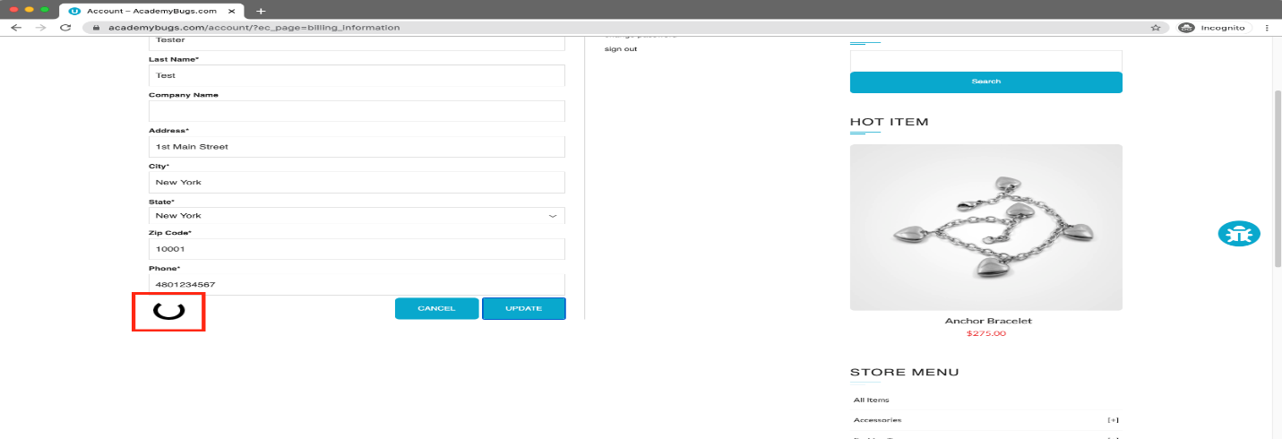

**Bug Id:25**

**Title:** In this bug, the My Space share page loads infinitely.

**Reporting Date:** 27/07/2022

**Reporter:** Hamza Quraish

###### Severity: Low

###### Priority: High

###### Issue Type: Performance

###### Frequency: Every Time

###### Environment: All Browsers/QA Environment

###### Action Performed

1. Open [**https://academybugs.com**](https://academybugs.com/)
2. Click the Find Bugs link on the navigation bar
3. Open a product
4. Click the My Space share link

###### Expected Result

The user is able to share the product through My Space

###### Actual Result

My Space share page loads infinitely

###### Attachments

